​​ Modoc Hall AV Guide

Modoc Hall Podium 2

Modoc Hall Podium Connections 3

Connecting your Laptop to the projector via HDMI 3

Connecting your Laptop to ShareLink using the ShareLink App 6

Connecting your Laptop to the projector via VGA and Audio Cable 13

Handheld Microphone 16

Lapel Microphone 18

# Modoc Hall Podium

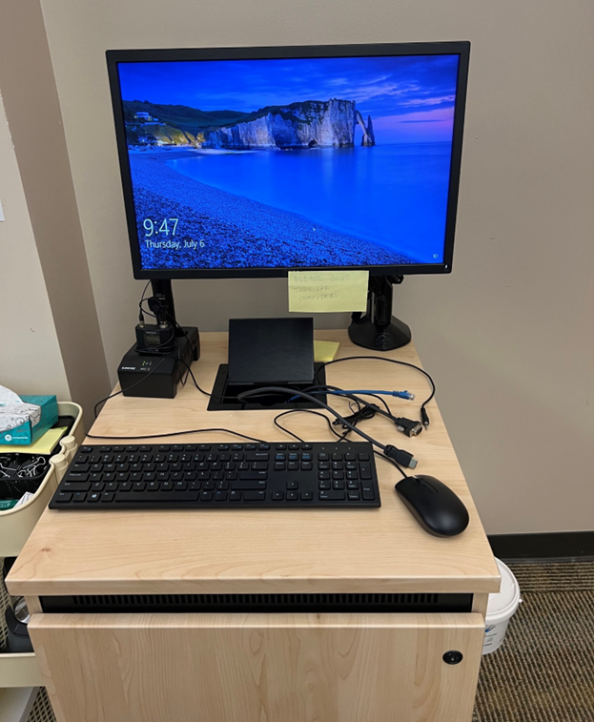

# Modoc Hall Podium Connections

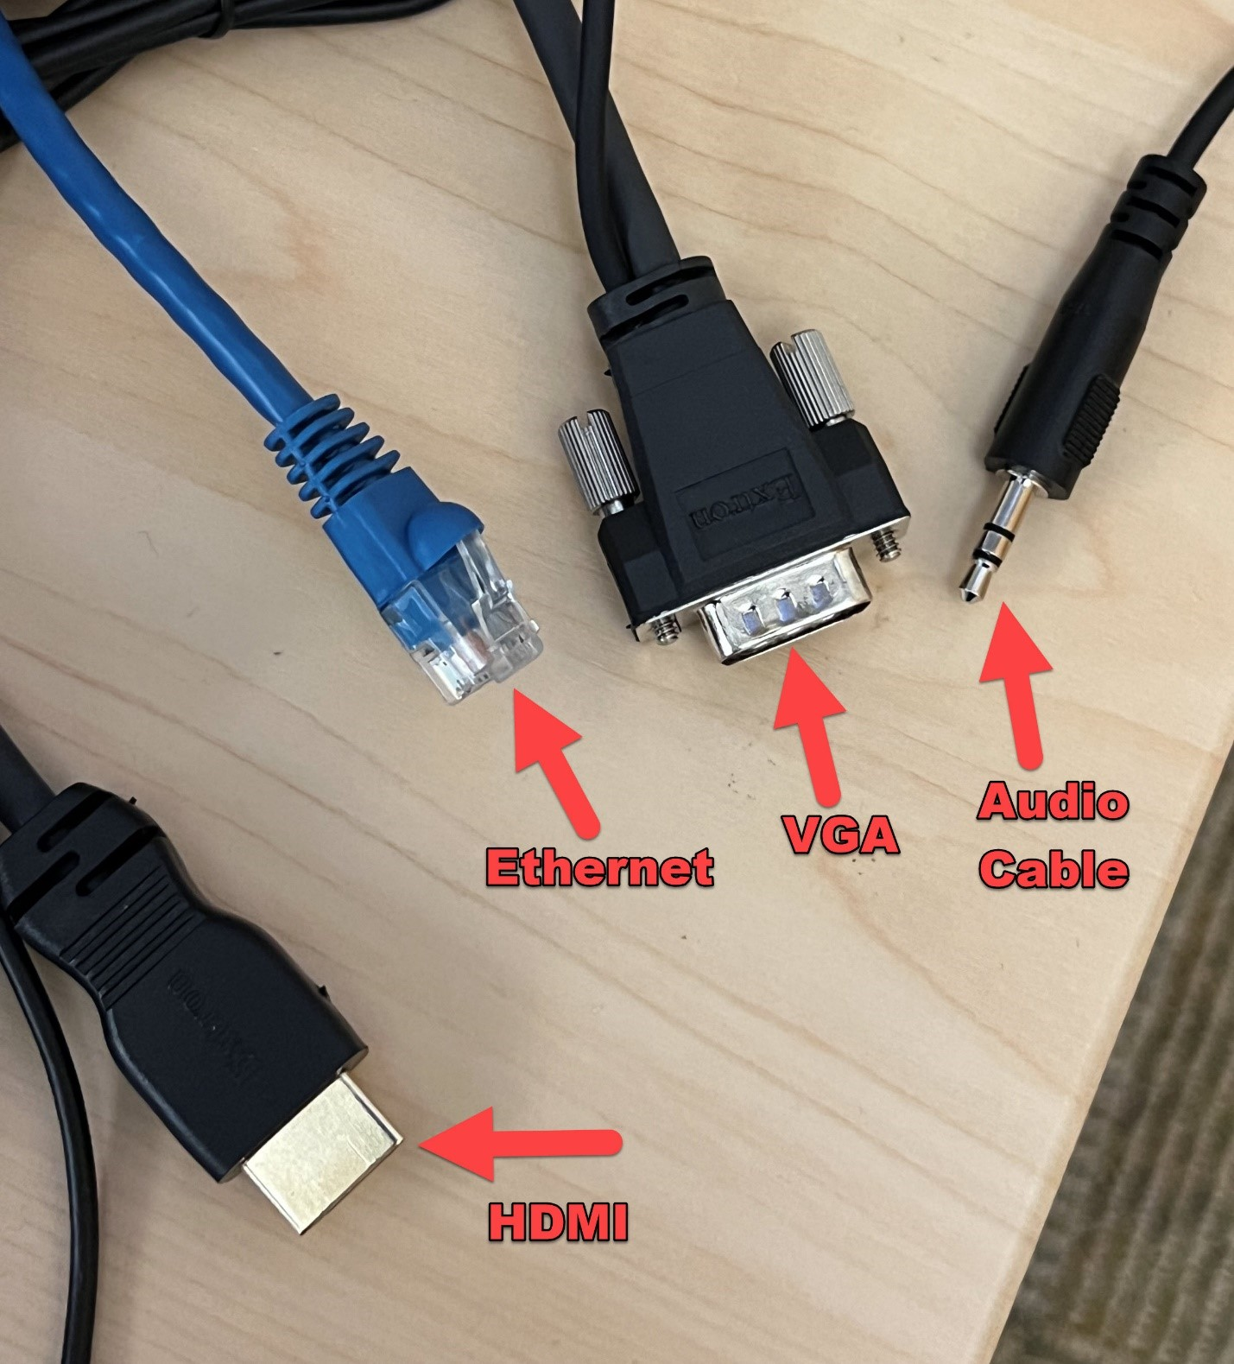

# Connecting your Laptop to the projector via HDMI

* Connect the podiums HDMI cable into the HDMI port on your computer.

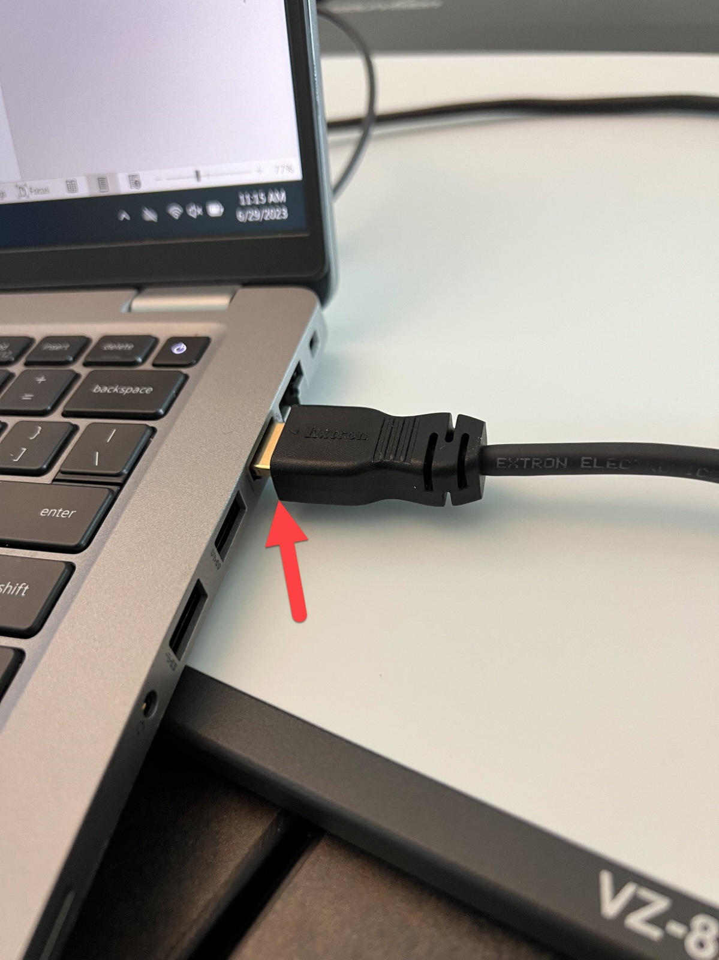

* Press the HDMI button on the projector’s control panel.

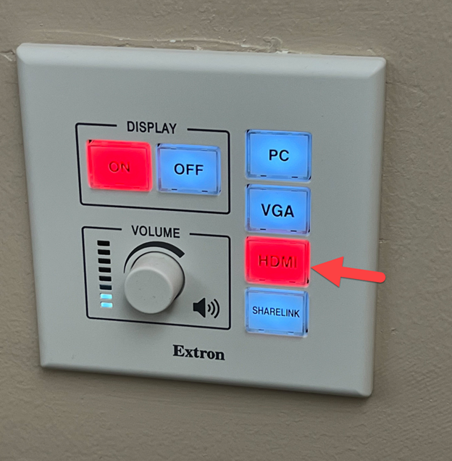

# Connecting your Laptop to ShareLink using the ShareLink App

* Press the ShareLink button on the projector’s control panel.

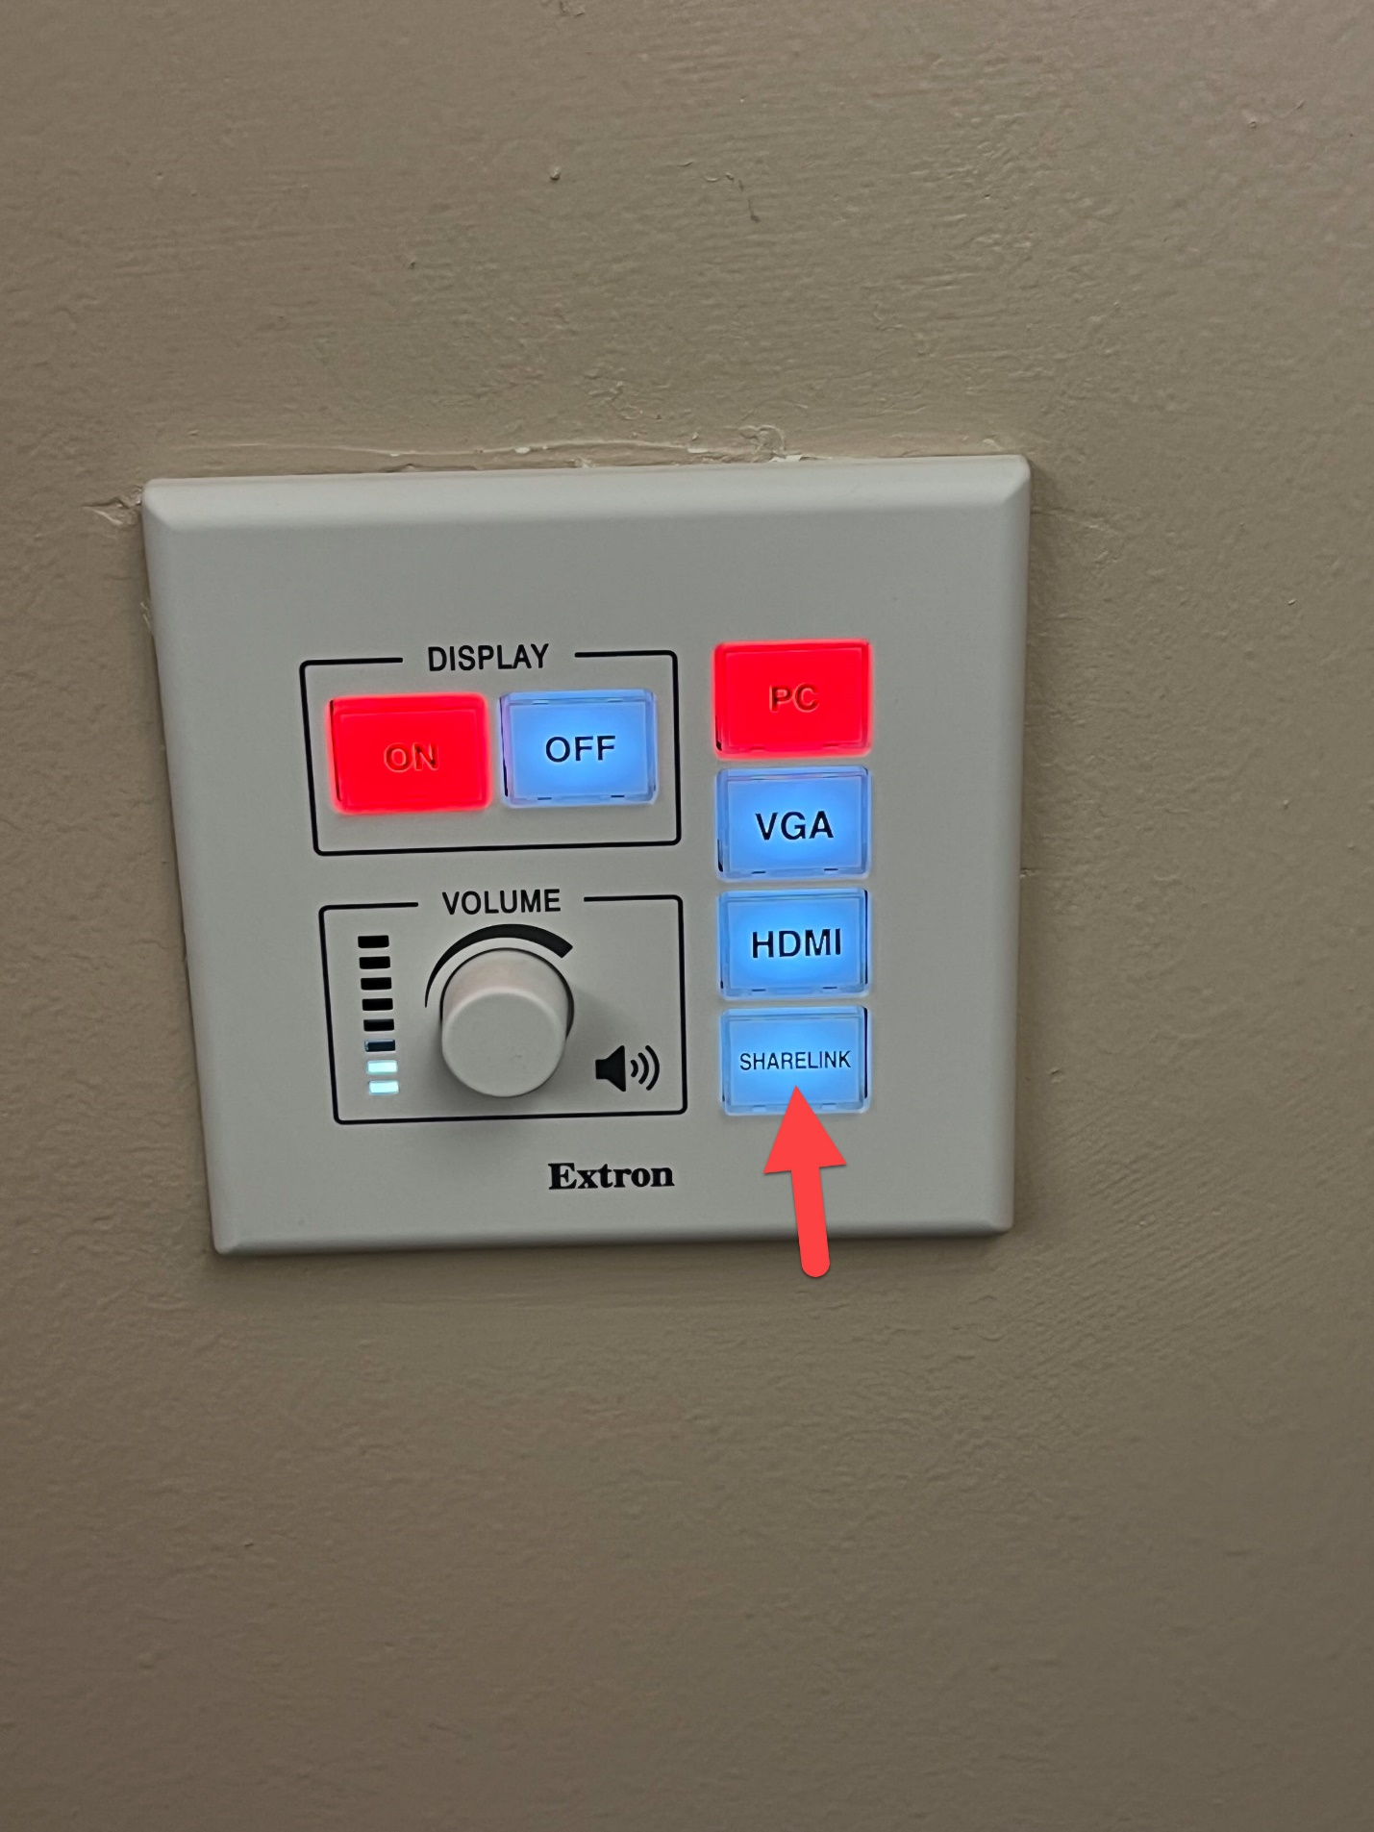

* The projector screen will come down and you will see this screen.
* On the bottom left of the screen you will see your devices IP Address.
* On the bottom right of the screen you will see your devices Code

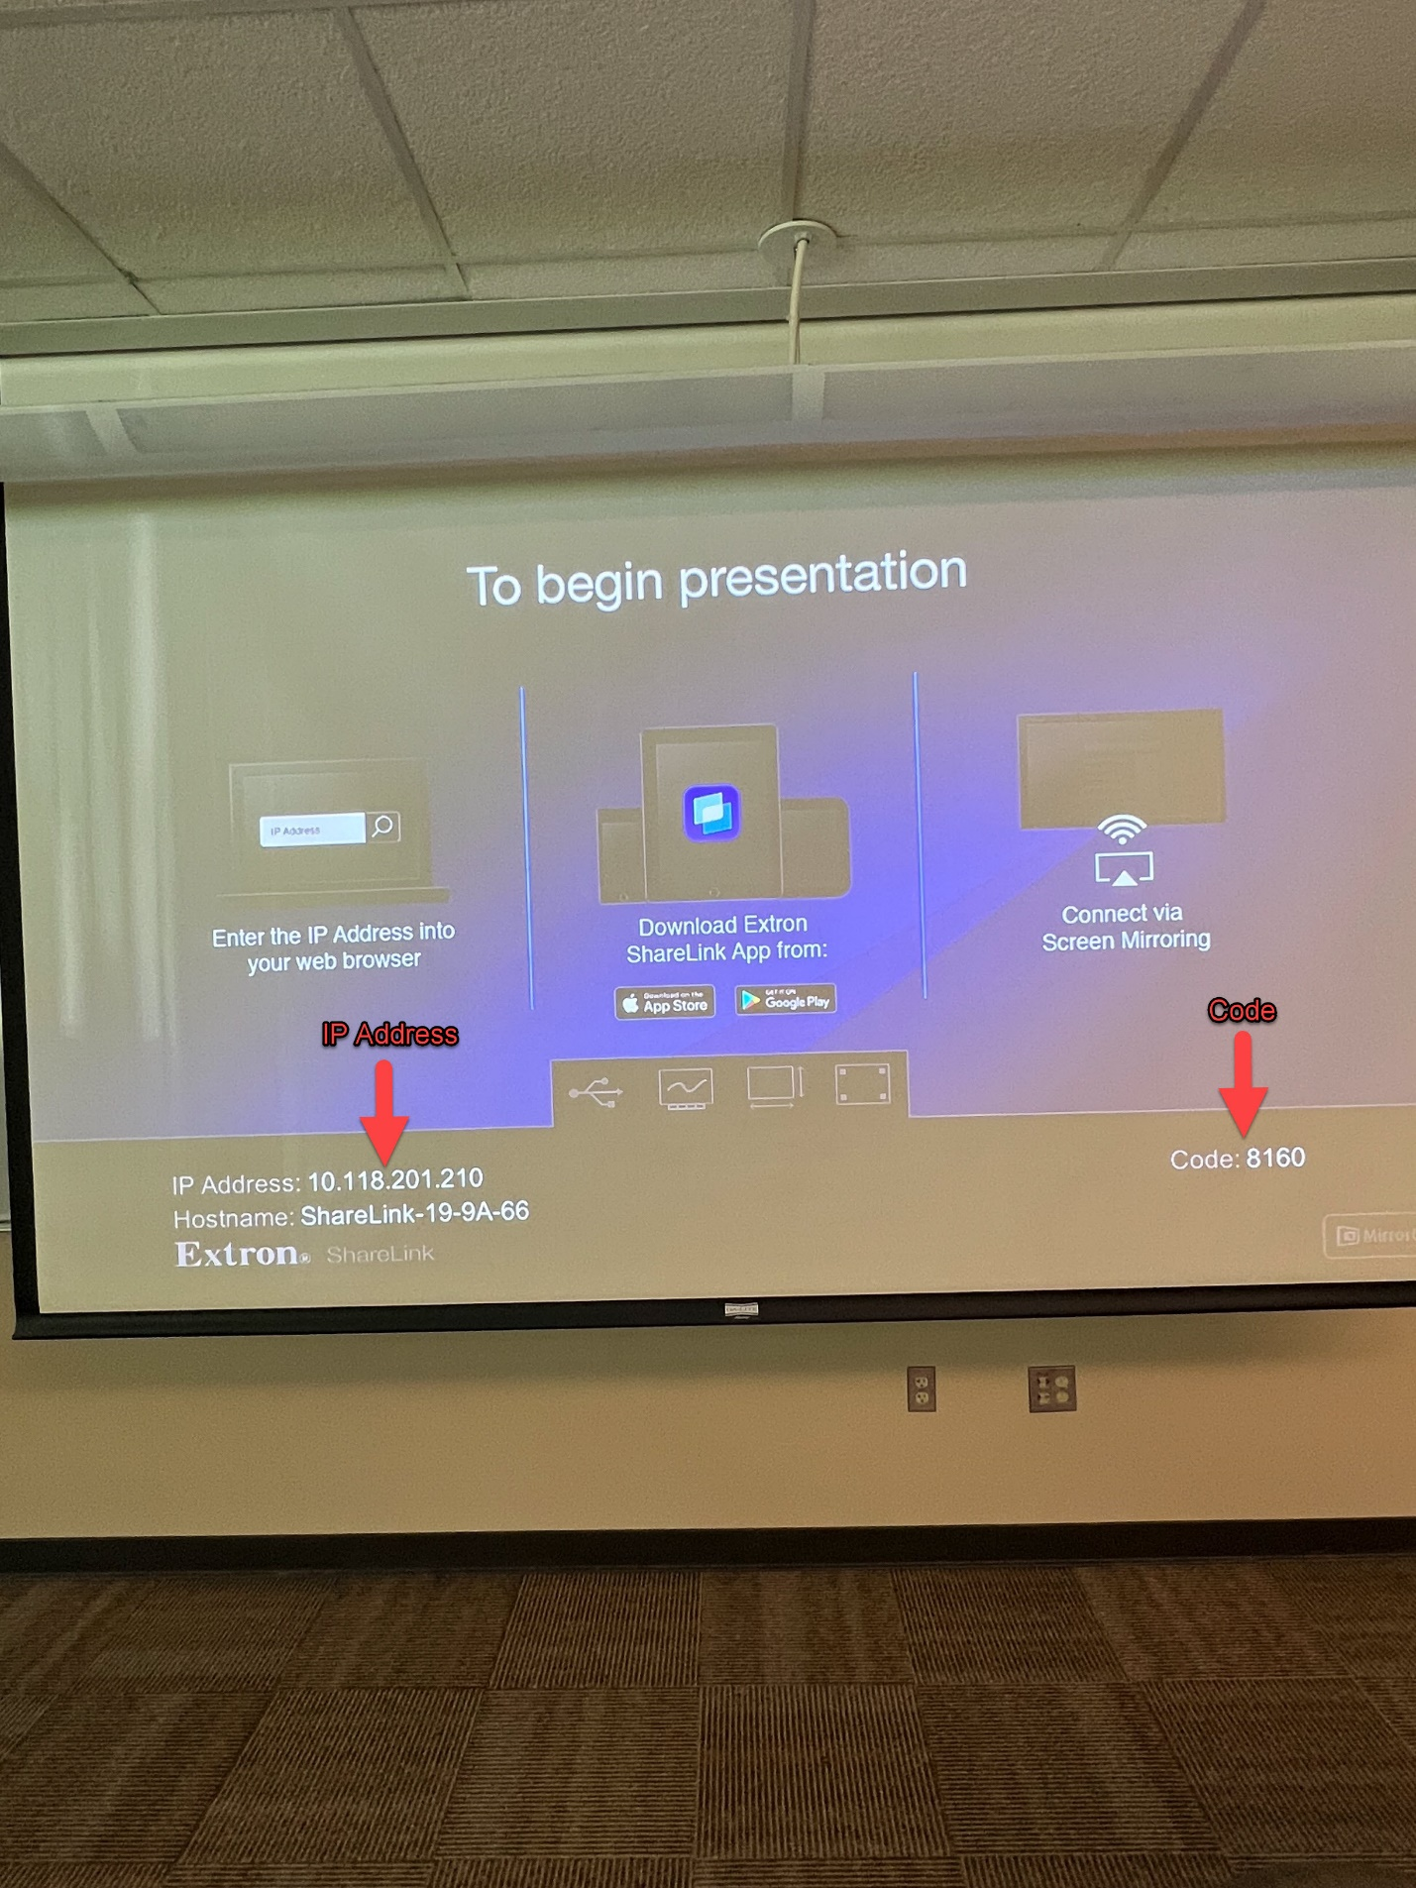

* Open the ShareLink app and type in the IP address.

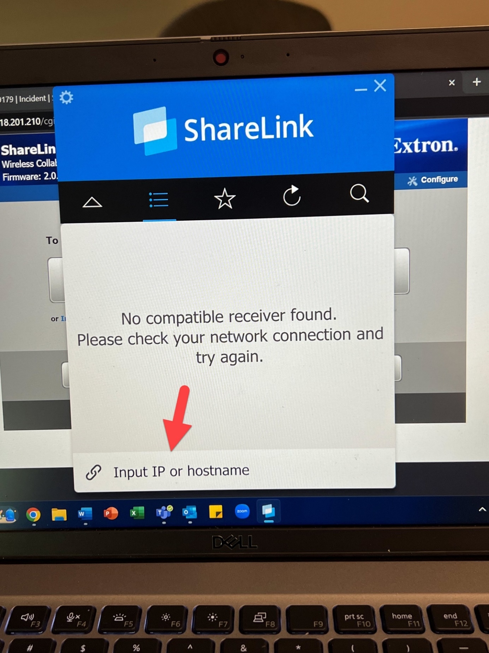

* Enter your devices code.

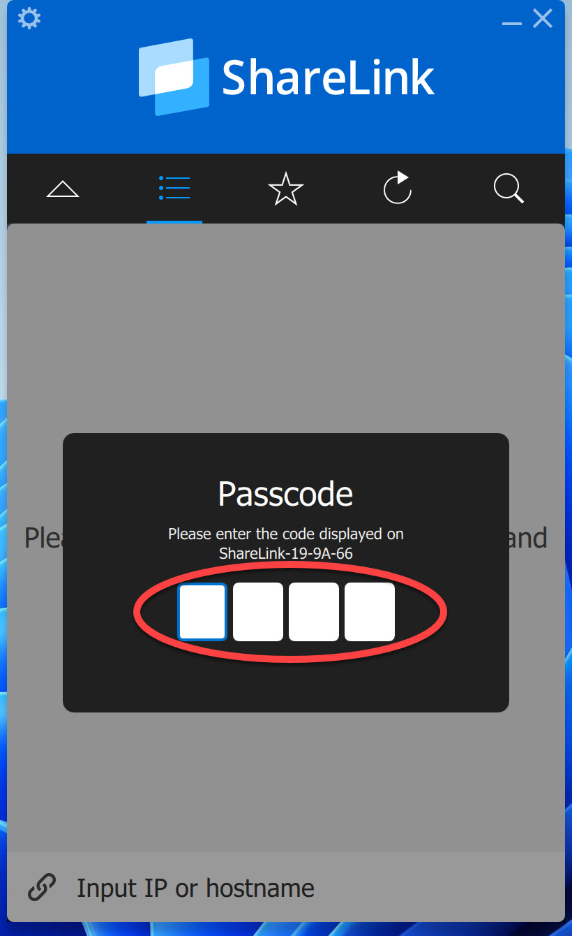

* Your device will now appear on the ShareLink app.
* Click this arrow to close the device list.

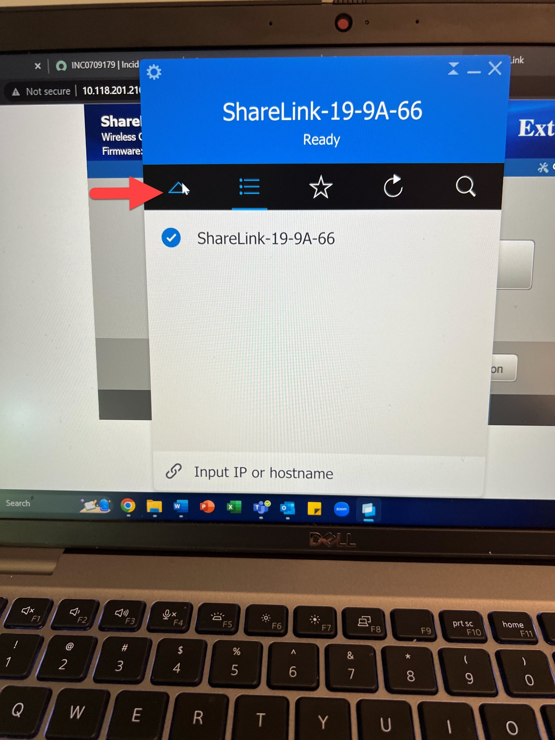

* Click the play button to start mirroring your screen.

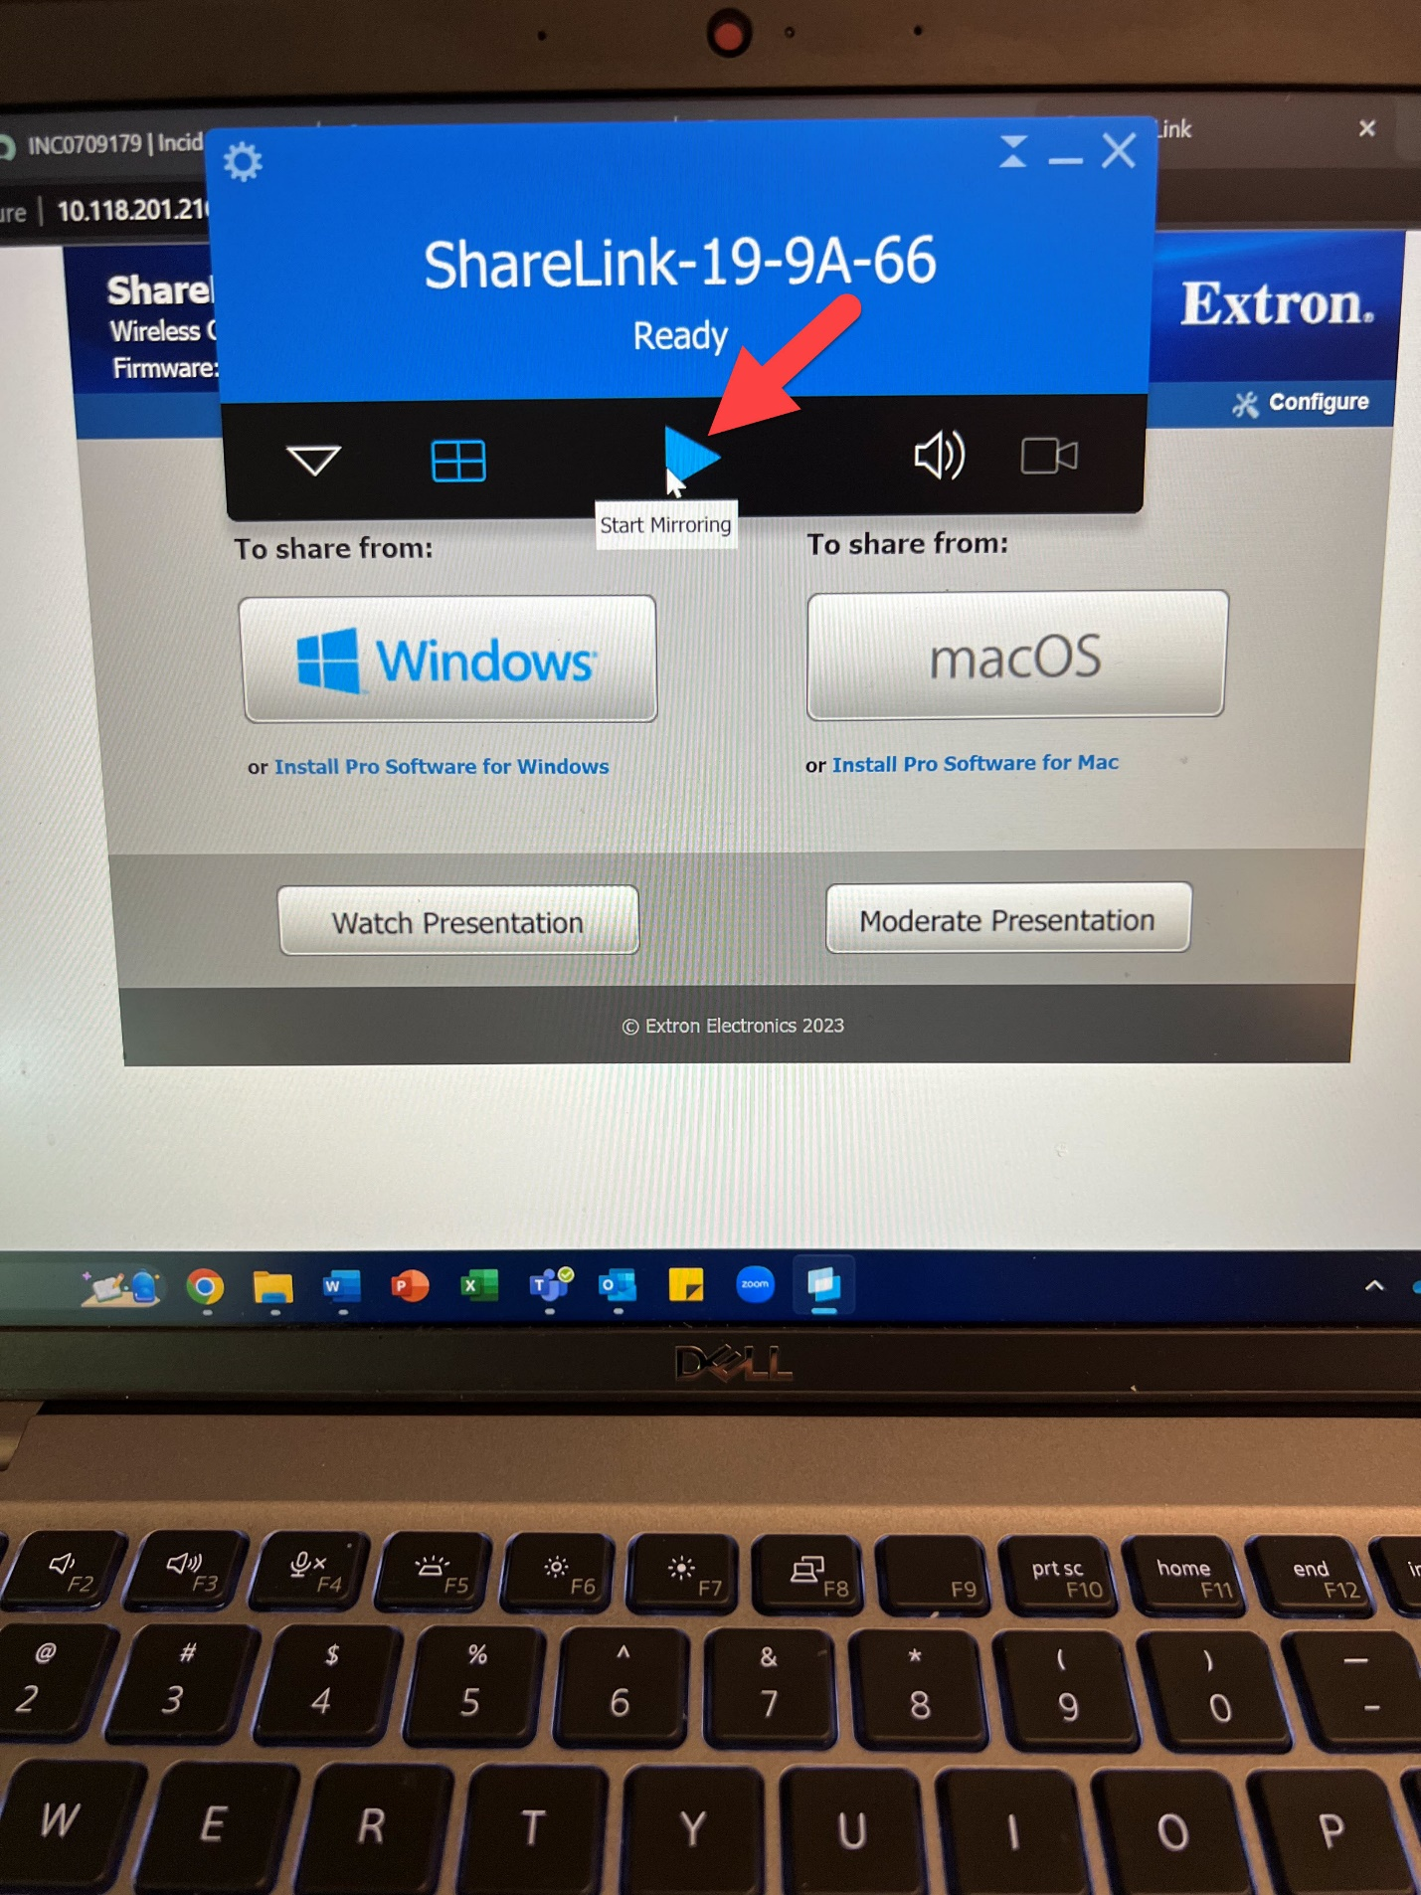

# Connecting your Laptop to the projector via VGA and Audio Cable

* Connect the podiums VGA cable to the VGA port on your computer.
* Connect the podiums Audio cable to the audio port on your computer.

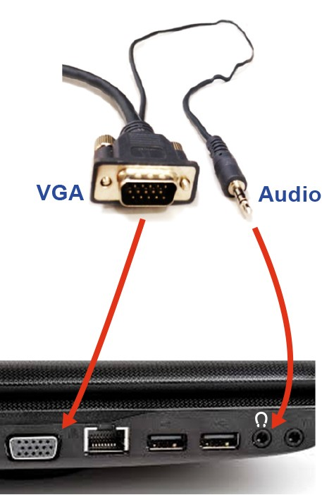

* Press the VGA button on the projector’s control panel.

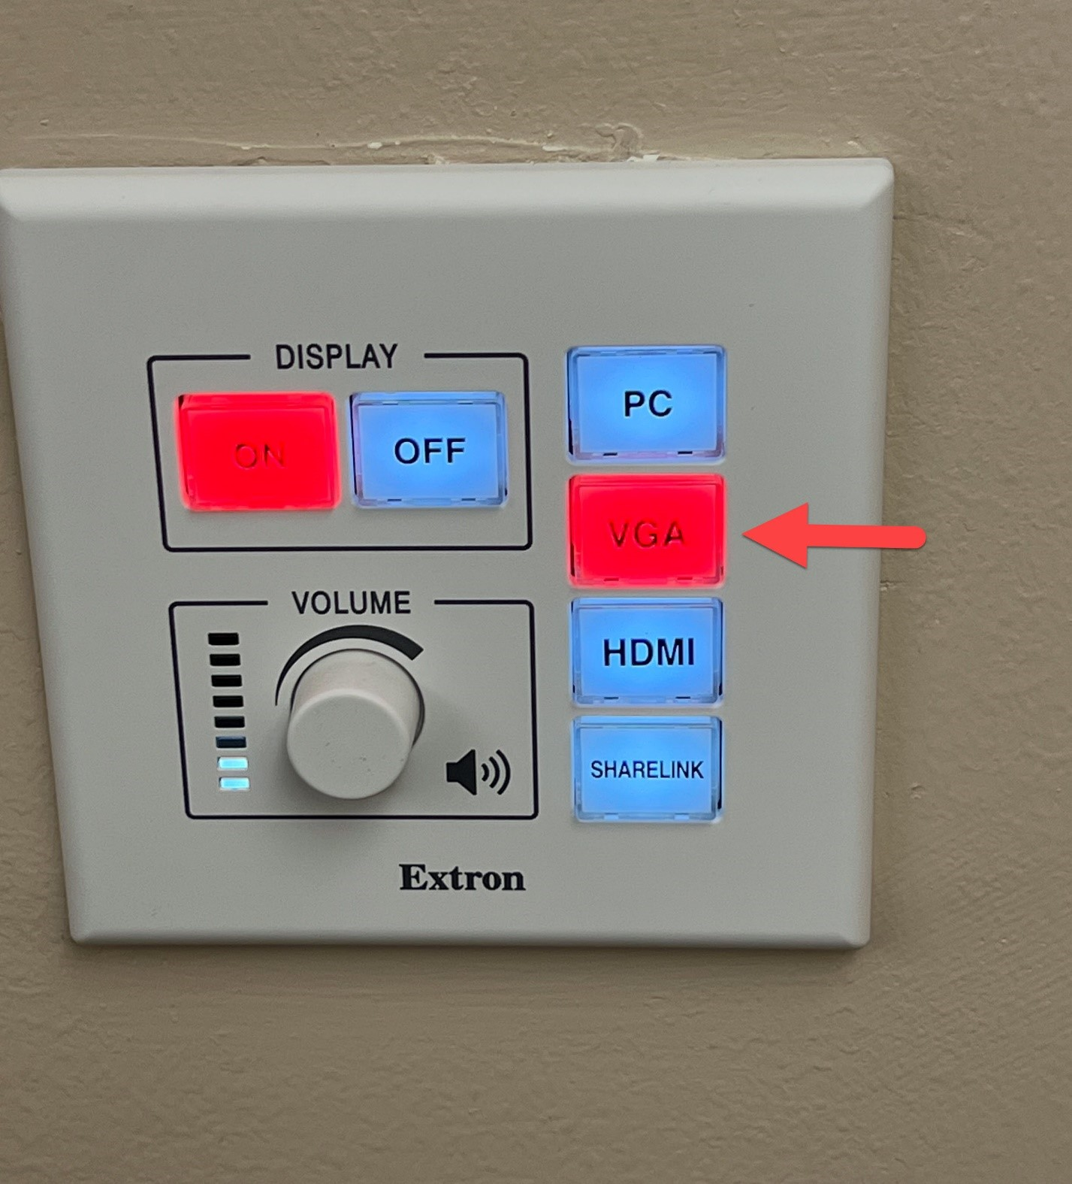

# Handheld Microphone

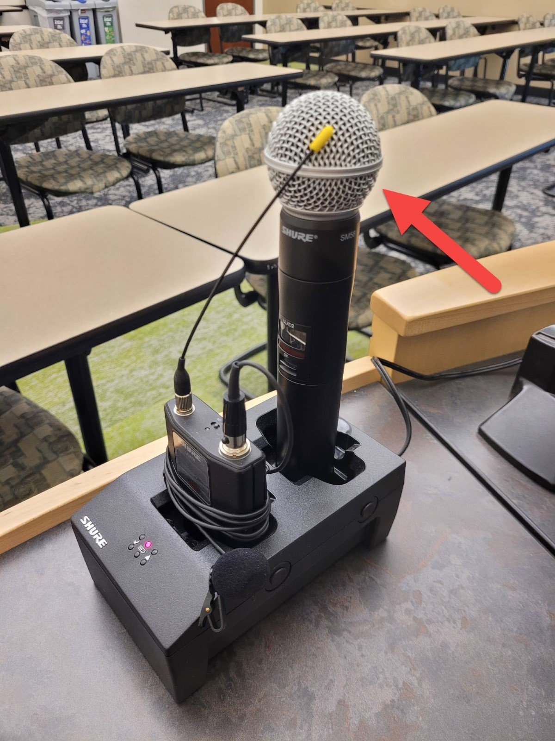

* Pull the handheld microphone out of its dock and move the switch up to the on position.

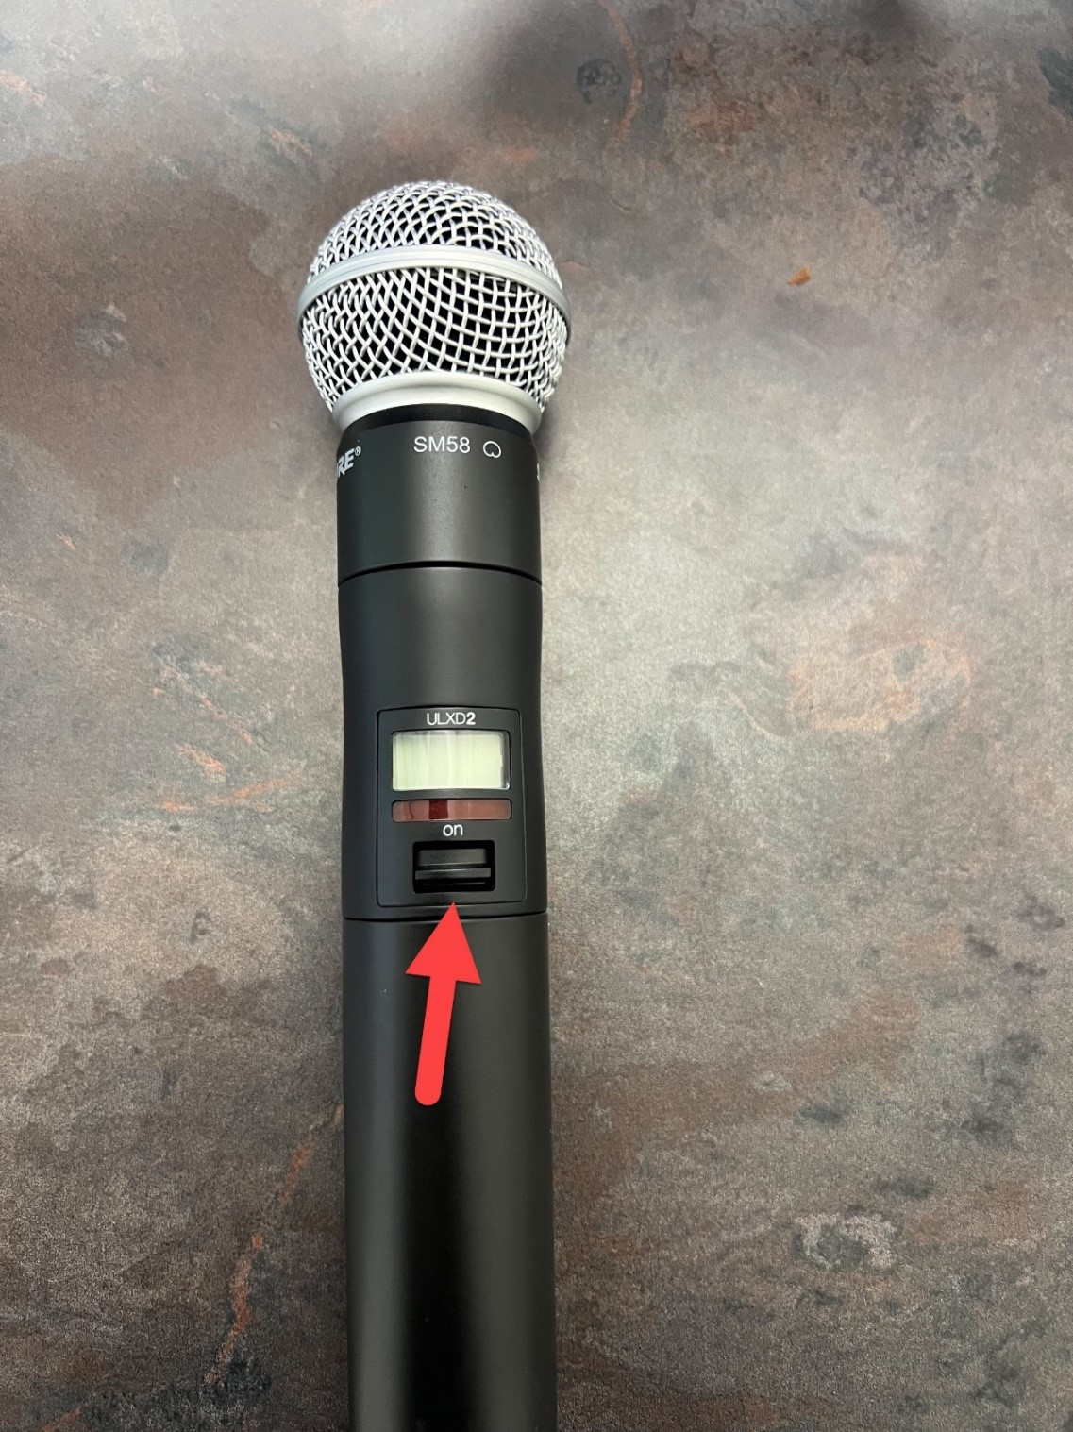

# Lapel Microphone

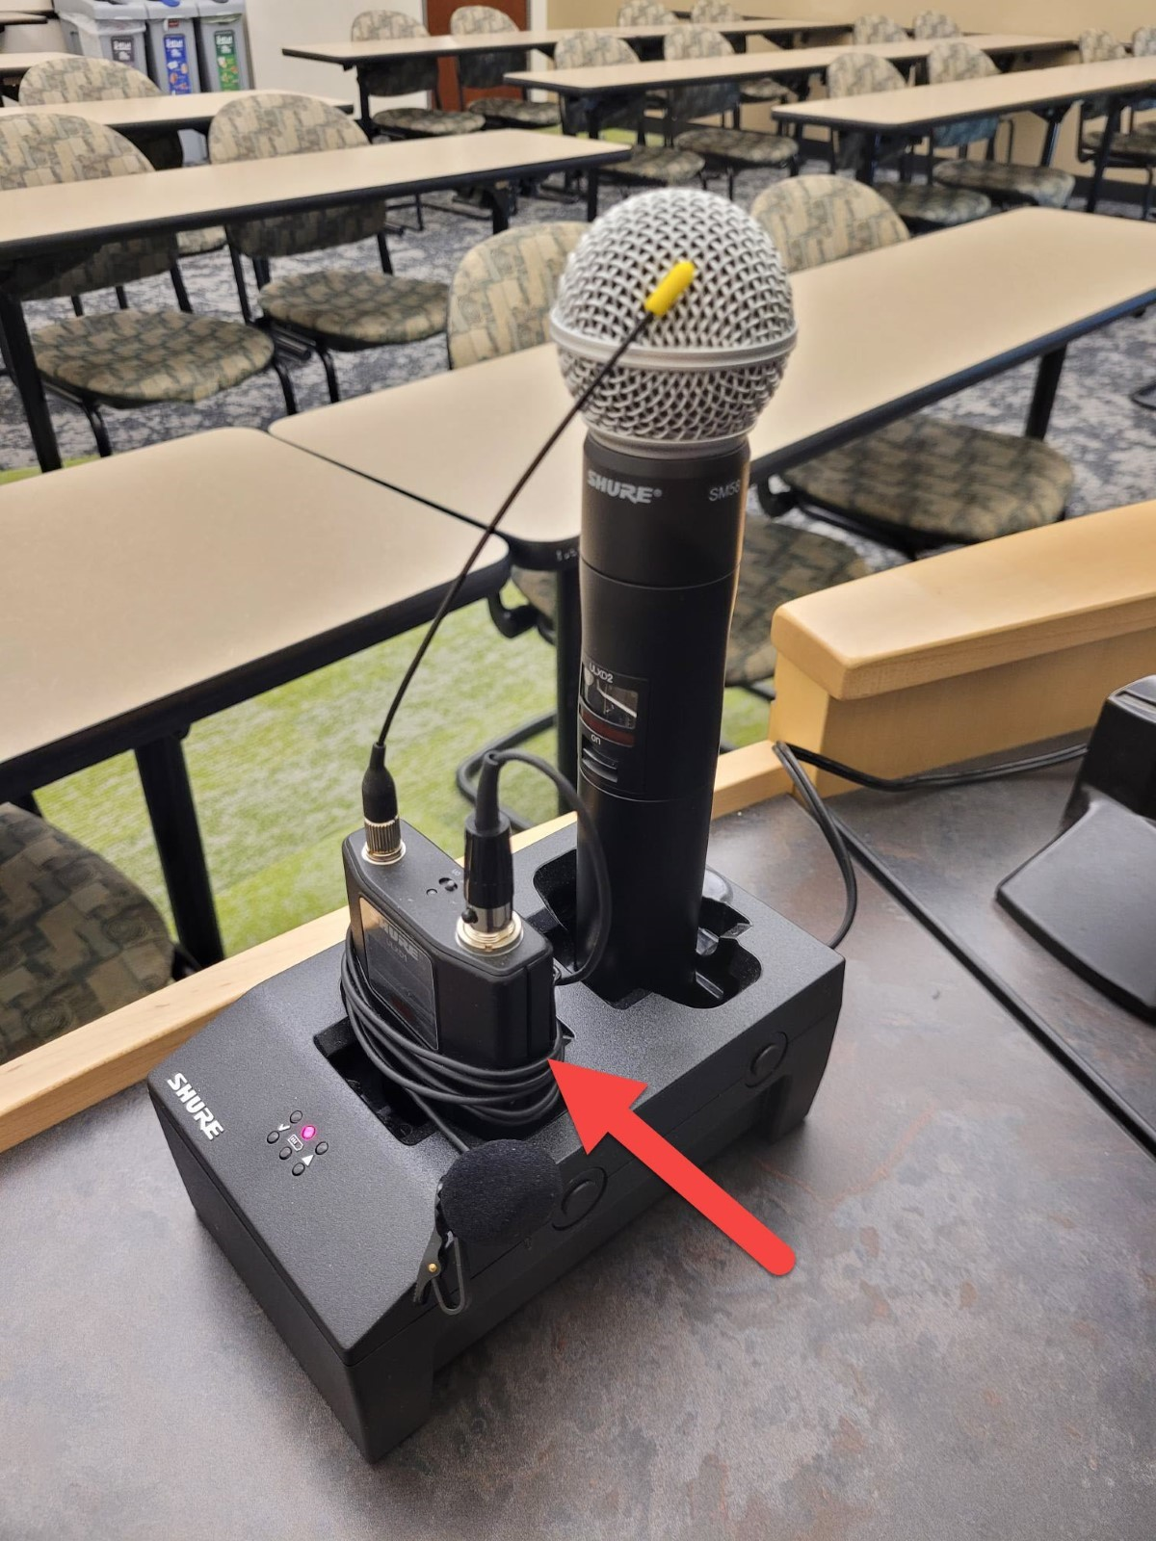

* Pull the Lapel microphone out of its dock.
* Locate the power switch on the top of the microphone and switch it to the on position.

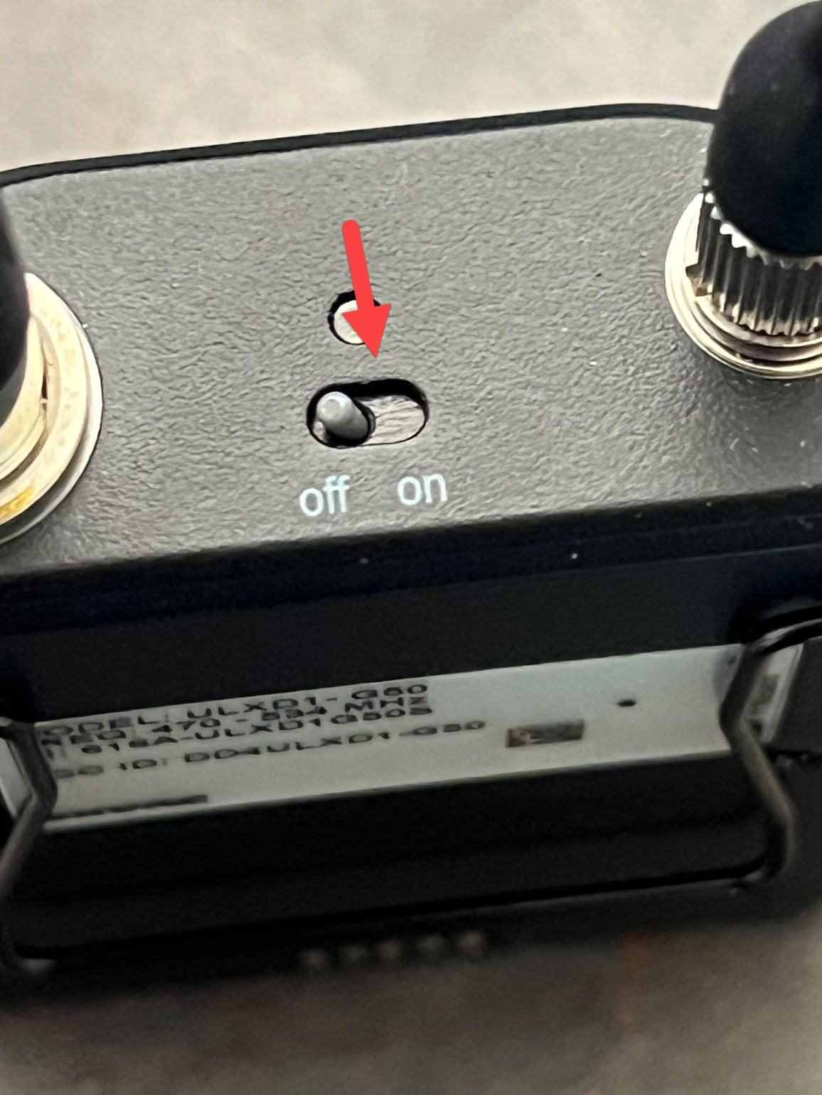

* You will speak into this piece of the microphone.
* This piece also has a clip so you can attach it to your shirt for easy access.

